**DAILY ONLINE ACTIVITIES SUMMARY**

|  |  |  |  |  |  |  |  |
| --- | --- | --- | --- | --- | --- | --- | --- |
| **Date:** | **06/06/2020** | | | | **Name:** | **Namratha C** | |
| **Sem & Sec** | **8th sem, A sec** | | | | **USN:** | **4AL16CS056** | |
| **Online Test Summary** | | | | | | | |
| **Subject** | | **IoT** | | | | | |
| **Max. Marks** | | **30** | | **Score** | | **30** | |
| **Certification Course Summary** | | | | | | | |
| **Course** | **Introduction to AWS Codebuild** | | | | | | |
| **Certificate Provider** | | | **Aws training and certification** | **Duration** | | | **10mins** |
| **Coding Challenges** | | | | | | | |
| **Problem Statement: 1) C Program to convert Decimal to Binary.** | | | | | | | |
| **Status: Completed** | | | | | | | |
| **Uploaded the report in Github** | | | | **Yes** | | | |
| **If yes Repository name** | | | | **CODES (Namrathasonu)** | | | |
| **Uploaded the report in slack** | | | | **Yes** | | | |

Online Test Details:

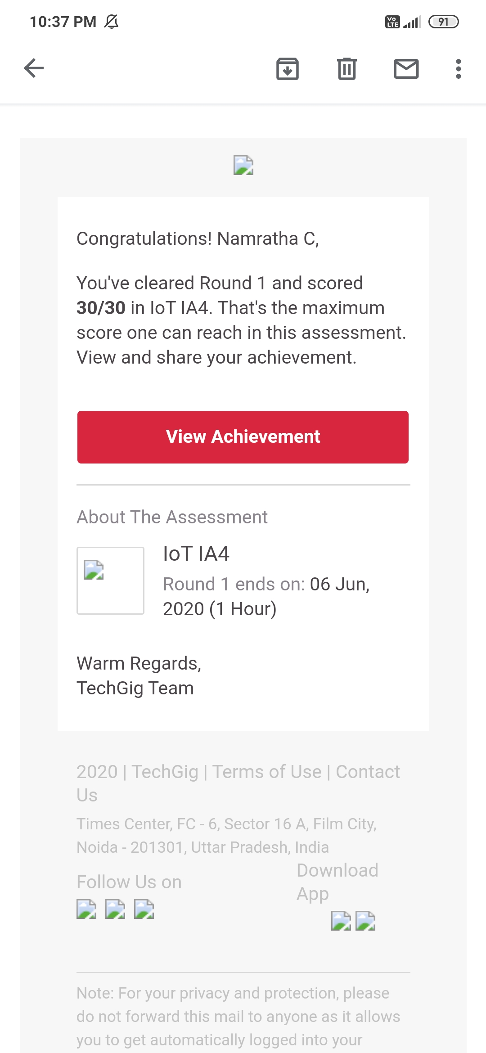

Certification Course Details:

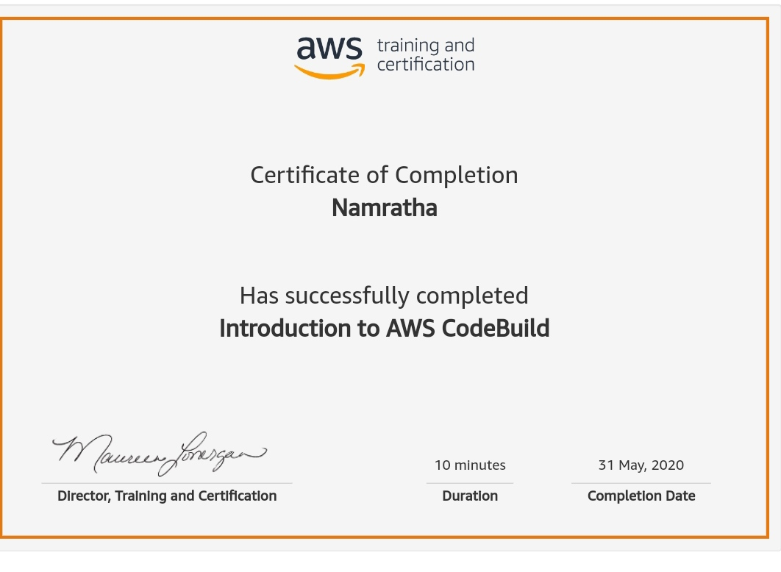

Coding Challenges Details:

1)

#include<studio.h>

#include<stdlib.h>

int main(){

int a[10],n,i;

system ("cls");

printf("Enter the number to convert: ");

scanf("%d",&n);

for(i=0;n>0;i++)

{

a[i]=n%2;

n=n/2;

}

printf("\nBinary of Given Number is=");

for(i=i-1;i>=0;i--)

{

printf("%d",a[i]);

}

return 0;

}